Project Design Phase-I Solution Architecture

|  |  |
| --- | --- |
| Date | 19 September 2022 |
| Team ID | PNT2022TMID52762 |
| Project Name | Project – Gas Leakage Monitoring and Alerting System for Industries |
| Team Members | Gokulan P (CITC1904009)  Jayanth A (CITC1904016)  Kishore R (CITC1904022)  Priyakanth G (CITC1904037) |

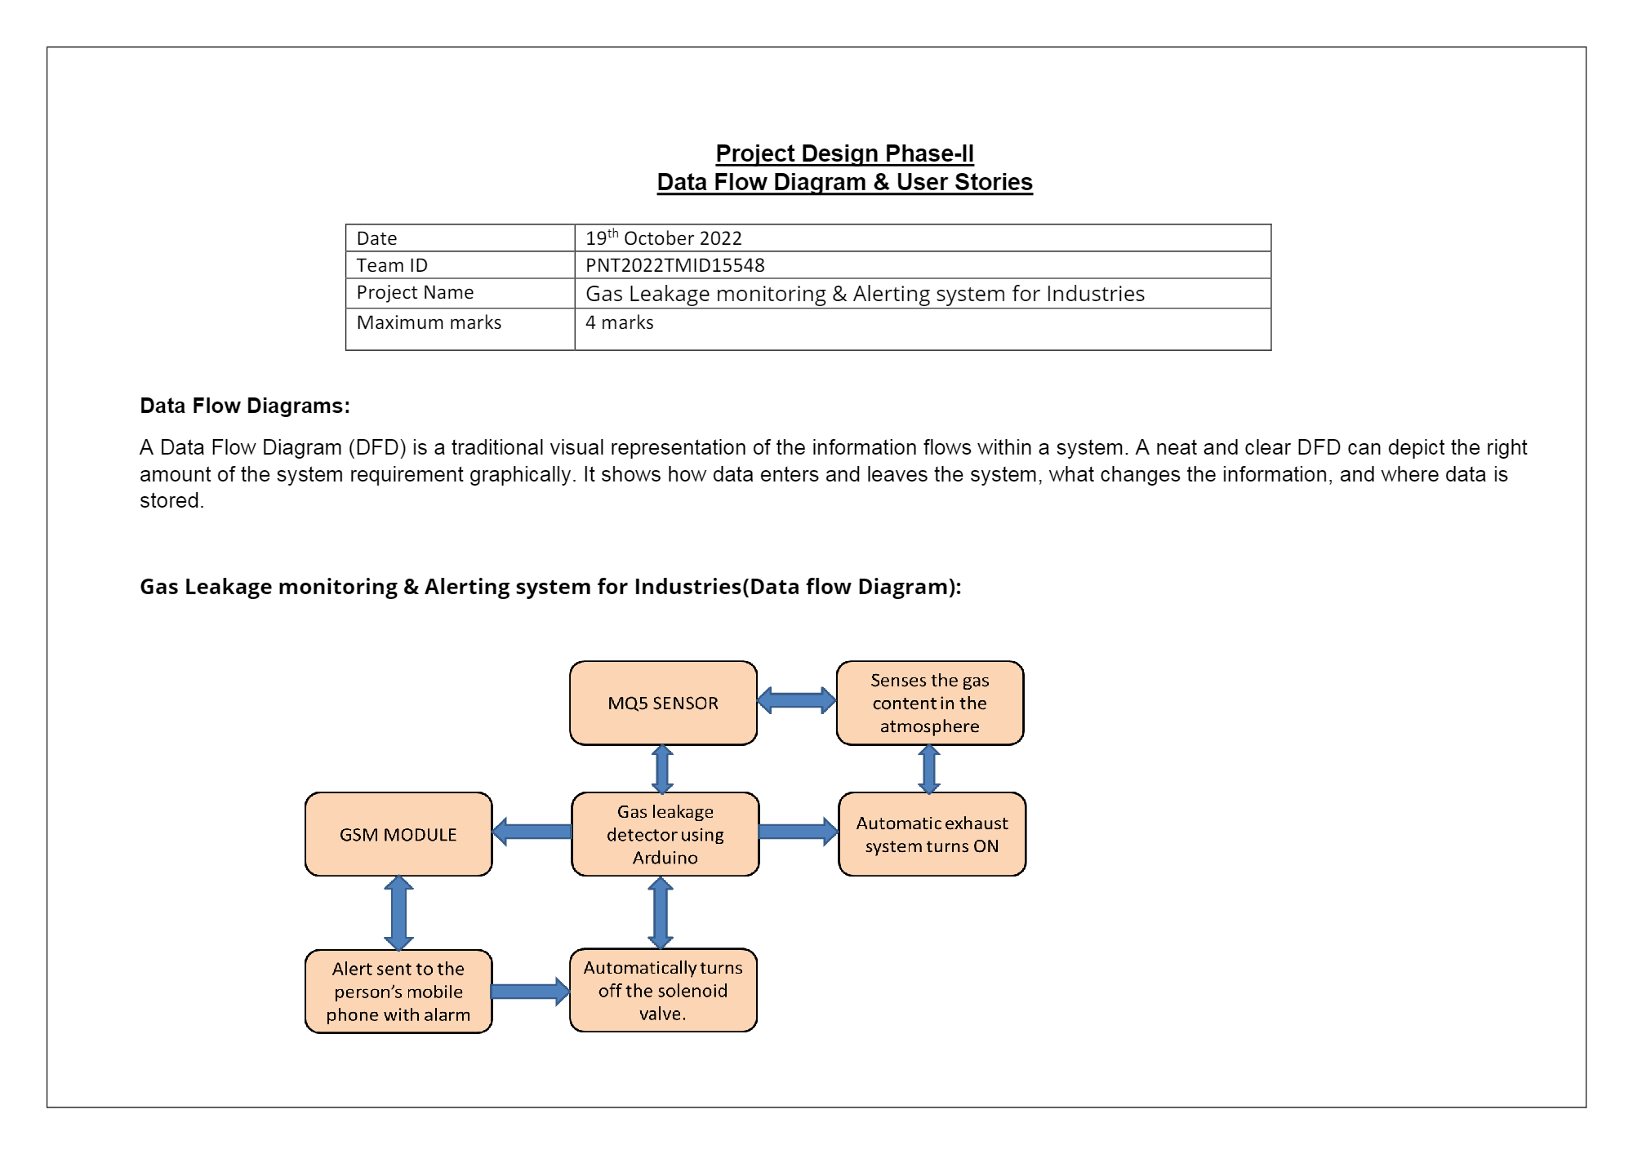

Figure 1: Architecture and data flow of the Gas Leakage Monitoring and Alerting System for Industries